Lesson 2. Algorithms for working with triangulated surface

Aim: How do we build a simple Facial Recognition App using API?

Objectives: After the lesson, students should be able to:
- Obtain basic understanding on facial recognition API

Do Now:
If we triangulate human faces, we will get a list of vertices (coordinates) of triangles. Check the image below, what conclusion can we draw?

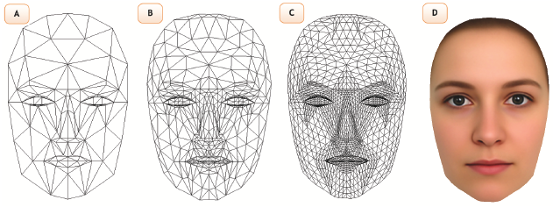

Class Discussion / Presentation:
- Geometry review:

- What is the definition and features of similar triangles?

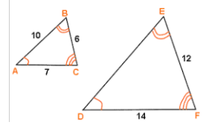

- How do we tell if two facial images are the same?

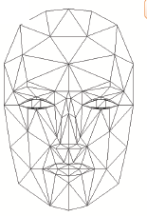

- If we know the coordinates of a triangle, after the rotation how can we find the coordinates of the triangle after the triangle?

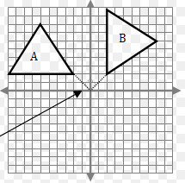

- How about rotating about the y-axis?
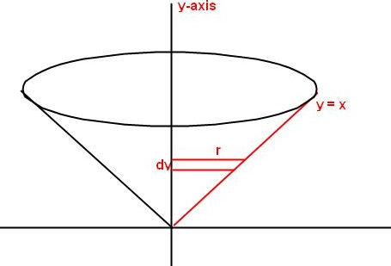

- How about rotating a 3D shape?

Pair – sharing Activity #1: How do we recognize the following shapes after rotation? Discuss with your partner and write the pseudo code in Java.

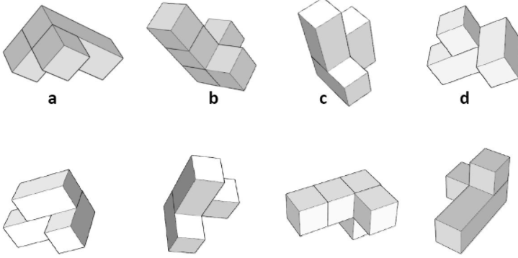

Pair – sharing Activity #2:
Our next project is the attendance app using facial recognition API. Research on how to output results from Android to Azure or Google doc.

